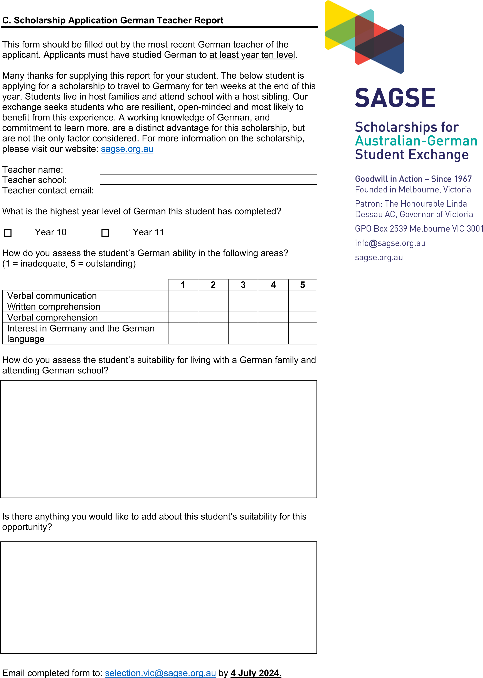

Please email completed form to [selection.vic@sagse.org.au](mailto:selection.vic@sagse.org.au) by **25th July 2025**

Note: **DO NOT** send a completed report to an applicant.